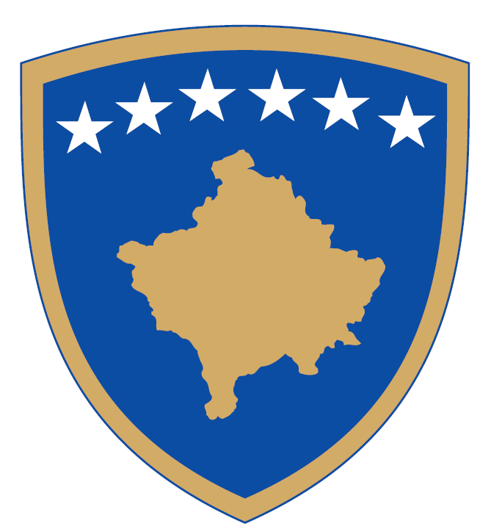 | Republika e Kosovës  Republika Kosova – Republic of Kosovo  Qeveria – Vlada – Government  Ministria e Punëve të Brendshme  Ministarstvo Unutrašnjih Poslova  Ministry of Internal Affairs | 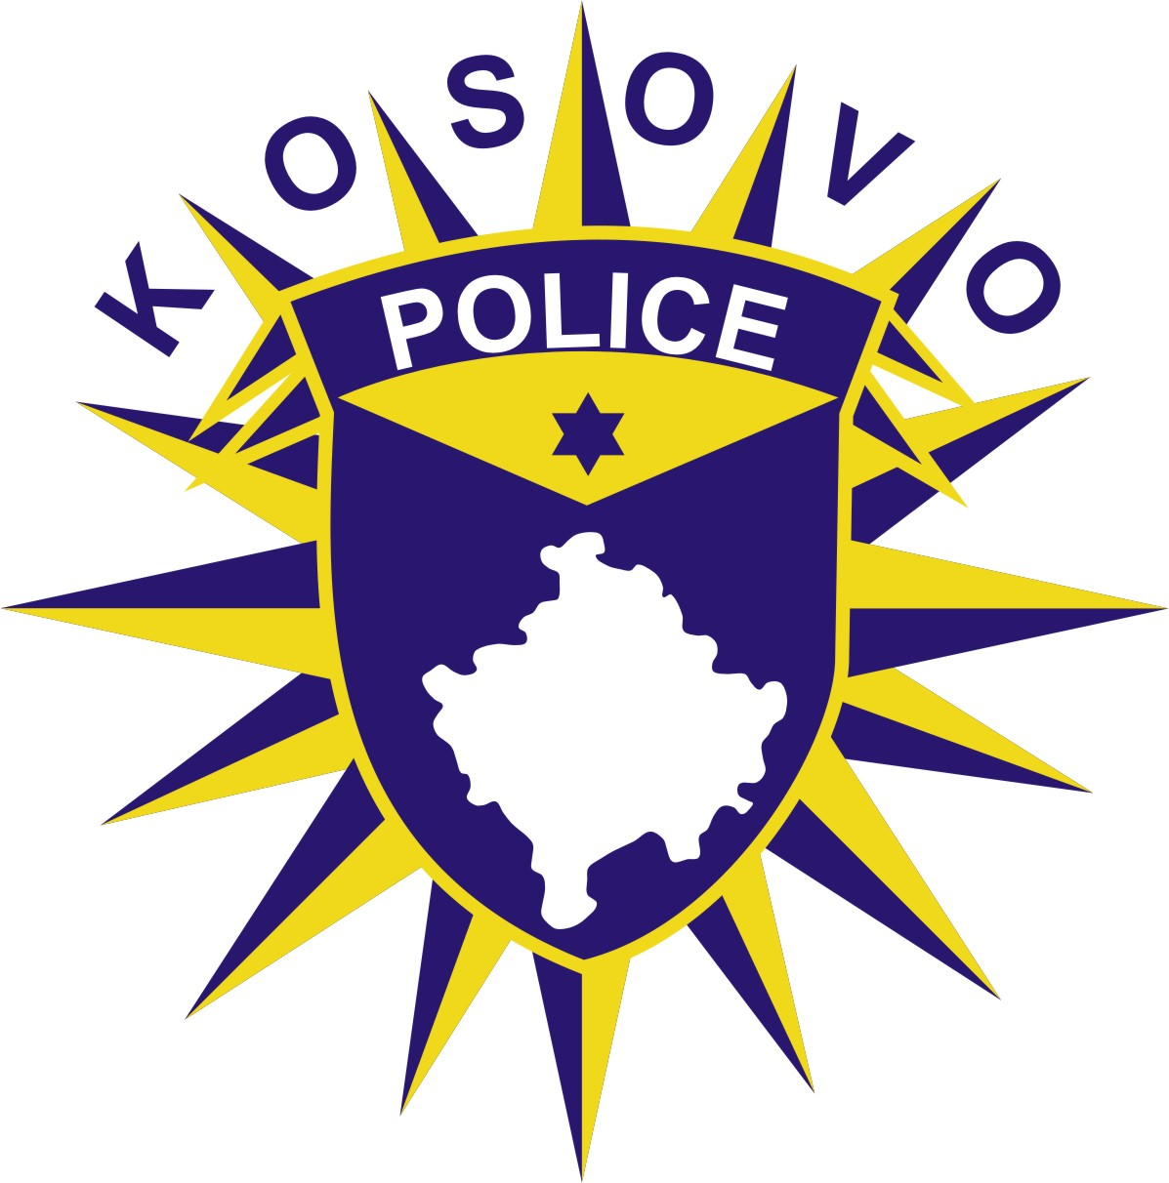
Drejtoria e Përgjithshme e Policisë
Generalna Policijska Direkcija/General Police Directorate

Date:___/___/_____

Pursuant to the article 17 paragraph 1, 2, 3 and 5 of the Law no. 08/L-166 on Public Gatherings, promulgated in the Official Gazette of the Republic of Kosovo, on 27 February 2023.

FORM FOR NOTIFICATION OF A PUBLIC EVENT

For the Police Station:

NOTIFICATION FOR A PUBLIC EVENT

1. Name Surname and other data of the organizer

2. Personal number

3. Birthplace and Residence

__________________________________________________________________________________
4. Measures to maintain order, peace and security along with the number of guardians

5. The contract with the private security company (if any)

6. The nature of the public event

7. Date, time and place of the event

8. Approximate number of participants

9. Permission to use the space from the relevant municipality or institution responsible for the management of the space where the public event will be held.

- The public event must be notified no later than seven (7) days before it happens, except otherwise provided by the Law on Public Gatherings.

- The notification for the public event is made through the public event notification form which is submitted by the organizer or his representative, physically to the nearest police station from the place where the public event will be held or electronically.

